**Name : Mohit Manish Bhavsar**

**Roll No : 20U437**

**Div : 4**

import pandas as pd  
df = pd.read_csv('Iris.csv')  
print(df)

Id SepalLengthCm SepalWidthCm PetalLengthCm PetalWidthCm \  
0 1 5.1 3.5 1.4 0.2   
1 2 4.9 3.0 1.4 0.2   
2 3 4.7 3.2 1.3 0.2   
3 4 4.6 3.1 1.5 0.2   
4 5 5.0 3.6 1.4 0.2   
.. ... ... ... ... ...   
145 146 6.7 3.0 5.2 2.3   
146 147 6.3 2.5 5.0 1.9   
147 148 6.5 3.0 5.2 2.0   
148 149 6.2 3.4 5.4 2.3   
149 150 5.9 3.0 5.1 1.8   
  
 Species   
0 Iris-setosa   
1 Iris-setosa   
2 Iris-setosa   
3 Iris-setosa   
4 Iris-setosa   
.. ...   
145 Iris-virginica   
146 Iris-virginica   
147 Iris-virginica   
148 Iris-virginica   
149 Iris-virginica   
  
[150 rows x 6 columns]

df.columns

Index(['Id', 'SepalLengthCm', 'SepalWidthCm', 'PetalLengthCm', 'PetalWidthCm',  
 'Species'],  
 dtype='object')

print(df.dtypes)

Id int64  
SepalLengthCm float64  
SepalWidthCm float64  
PetalLengthCm float64  
PetalWidthCm float64  
Species object  
dtype: object

df.describe

<bound method NDFrame.describe of Id SepalLengthCm SepalWidthCm PetalLengthCm PetalWidthCm \  
0 1 5.1 3.5 1.4 0.2   
1 2 4.9 3.0 1.4 0.2   
2 3 4.7 3.2 1.3 0.2   
3 4 4.6 3.1 1.5 0.2   
4 5 5.0 3.6 1.4 0.2   
.. ... ... ... ... ...   
145 146 6.7 3.0 5.2 2.3   
146 147 6.3 2.5 5.0 1.9   
147 148 6.5 3.0 5.2 2.0   
148 149 6.2 3.4 5.4 2.3   
149 150 5.9 3.0 5.1 1.8   
  
 Species   
0 Iris-setosa   
1 Iris-setosa   
2 Iris-setosa   
3 Iris-setosa   
4 Iris-setosa   
.. ...   
145 Iris-virginica   
146 Iris-virginica   
147 Iris-virginica   
148 Iris-virginica   
149 Iris-virginica   
  
[150 rows x 6 columns]>

import seaborn as sns  
import matplotlib  
import matplotlib.pyplot as plt  
  
fig, axes = plt.subplots(figsize=(6,8))  
axes.set_title('Distribution of SepalLengthCm')  
  
axes.hist(df['SepalLengthCm'],bins=10)  
plt.show()

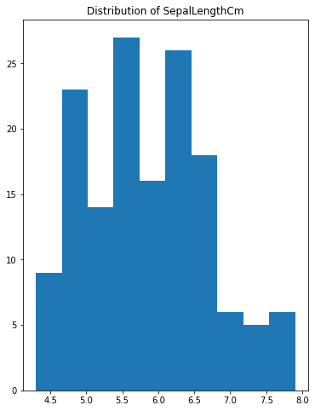

fig, axes = plt.subplots(figsize=(6,8))  
axes.set_title('Distribution of SepalWidthCm')  
axes.hist(df['SepalWidthCm'],bins=10)  
plt.show()

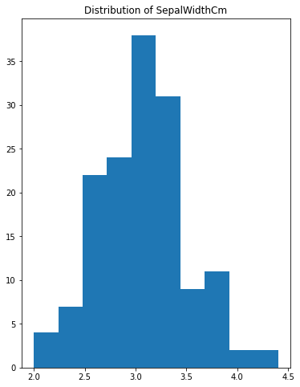

fig, axes = plt.subplots(figsize=(6,8))  
axes.set_title('Distribution of PetalLengthCm')  
axes.hist(df['PetalLengthCm'],bins=10)  
plt.show()

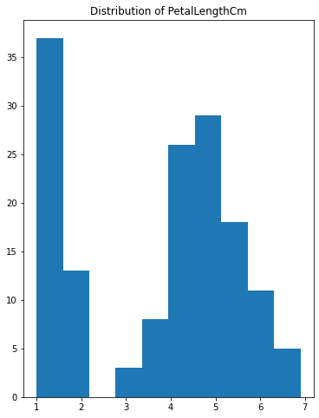

fig, axes = plt.subplots(figsize=(6,8))  
axes.set_title('Distribution of PetalWidthCm')  
axes.hist(df['PetalWidthCm'],bins=10)  
plt.show()

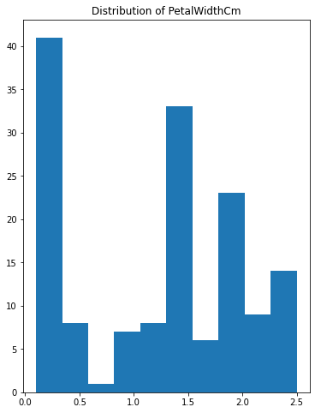

fig, axes = plt.subplots(figsize=(10,7))  
axes.set_title('Distribution of SepalLengthCm')  
axes.boxplot(df['SepalLengthCm'])  
plt.show()

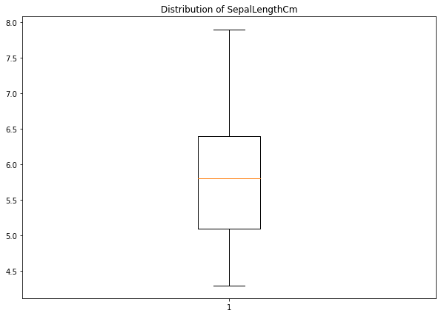

fig, axes = plt.subplots(figsize=(10,7))  
axes.set_title('Distribution of SepalWidthCm')  
axes.boxplot(df['SepalWidthCm'])  
plt.show()

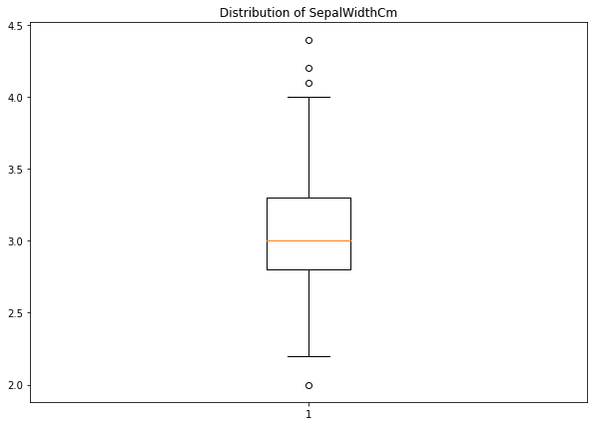

fig, axes = plt.subplots(figsize=(10,7))  
axes.set_title('Distribution of PetalLengthCm')  
axes.boxplot(df['PetalLengthCm'])  
plt.show()

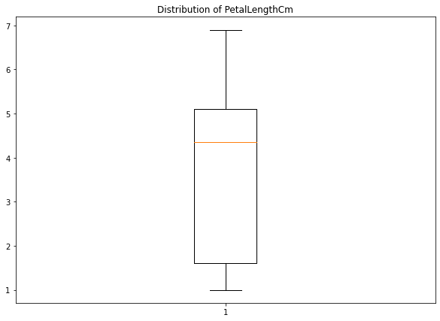

fig, axes = plt.subplots(figsize=(10,7))  
axes.set_title('Distribution of PetalWidthCm')  
axes.boxplot(df['PetalWidthCm'])  
plt.show()

